Example of Indexed tariff calculation in Spain
The indexed tariff is the hourly electricity price varying with each type of consumer (small, medium or large scale) linked to the hourly electricity market price in Spain plus the costs associated to the commercialization and distribution. It is calculated as per Equation (9.1) from [1]
$$PH=1.015·\left[\left(PHM+Pc+Sc+Dsv+GdO+POsOm\right)·\left(1+loss\right)+FE+F\right]+PTD+CA$$ | (9.1)
Where:
PH: the hourly electricity indexed price resulting from the equation above expressed in €/MWh.
PHM: the hourly market electricity price, expressed in €/MWh, is determined by the designated electricity market operator (OMIE in Spanish) through an algorithmic process that balances supply demand and sale. This price is published at 12:00 for the following 24-hour period and serves as the most influential factor in shaping the final electricity cost. Data on PHM can be found in references [2], [3]. This price applies exclusively to the Iberian Peninsula, whilst for the Canary and Balearic Islands, the Spanish Electricity Grid Operator (REE in Spanish) is responsible for calculating electricity costs. Figure 9.10 shows the PHM (€/MWh) data from 1st June 2023 to 31st May 2024.
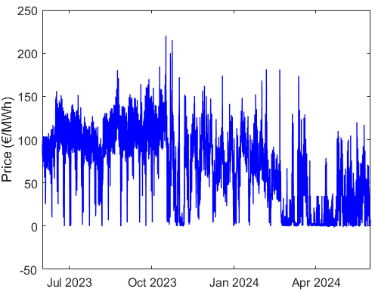
Figure 9.10. Hourly market electricity price (PHM).
Pc: the regulated capacity payment covers the cost of ensuring the availability of generation technologies that the electricity system may require at any given time. This fee is defined by the access tariff, which varies based on the type of consumer, hour of the day, day of the week and month. This value can be found at [4] or directly given by the Spanish Electricity Grid Operator [5] (REE in in Spanish). Within the REE’s database, the folder named ‘CX_Liquicomun’, (where ‘X’ indicates the latest version) contains the file of the hourly capacity payment for each type of consumer and each month of the year: ‘prpcap20TD’, ‘prpcap30TD’ and ‘prpcap61TD’ for the small, medium, and large consumer tariffs respectively. Figure 9.11 depicts the capacity payment for a large consumer (‘prpcap61TD’) from 1st June 2023 to 31st May 2024.
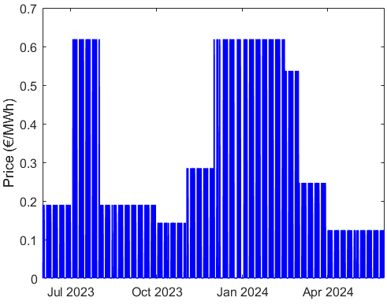
Figure 9.11. Hourly capacity payment (Pc).
Sc: the adjustment services charge is an additional cost applied to cover real-time technical restrictions and system balancing actions required to maintain grid stability. This fee fluctuates hourly, depending on the operational demands of the electricity system. The updated hourly Sc values can be found in [5], within the same ‘CX_Liquicomun’ directory, in the file ‘prdemCad’’ for each month of the year. Figure 9.12 depicts the hourly Sc between 1st of June 2023 to 31st of May 2024 for a large consumer (‘C2_Liquicomun/prdemCad’).
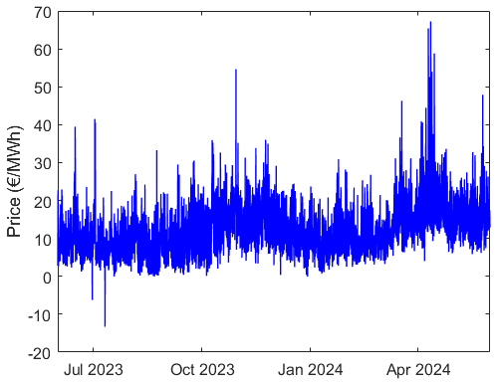
Figure 9.12. Hourly adjustment services charge (Sc).
Dsv: the deviation penalty cost is applied to compensate for imbalances between the scheduled energy and the actual energy demand. It is calculated according to Eq. (9.2) for the Iberian Peninsula:
$$Dsv=\left[\frac{1}{2}·\left(CoDsvSu+CoDsvBa\right)+BS3+RAD3\right]·factor_{Dsv}$$ | (9.2)
Where the deviation (Dsv) depends on the upward and downward imbalance costs (CoDsvSu and CoDsvBa) found in the CX_Liquicomun’ folder [5] in the files ‘CX_codsvsub’ and ‘CX_codsvbaj’’ respectively for each month of the chosen year. See Figure 9.13 and Figure 9.14 with the sourced data between 1st of June 2023 to 31st of May 2024 for a large consumer. $BS3$ corresponds to the Secondary Band price (BS3 in ‘CX_compodem’), and $RAD3$ to the Daily Adjustment Reference (RAD3 in ‘CX_compodem’). Figure 9.15 and Figure 9.16 depict BS3 and RAD3 data between 1st of June 2023 to 31st of May 2024. These parameters are multiplied by the mismatch factor ($factor_{Dsv}$), which depends on the electricity provider. In this case the electricity provider is assumed to be Som Energia, for which the deviation factor is 14% [6]. The deviation penalty cost resulting from Eq. (9.2) is shown in Figure 9.17.
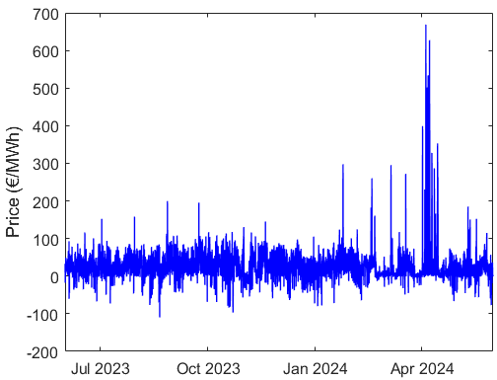
Figure 9.13. Hourly increased mismatch cost (CoDsvSu).
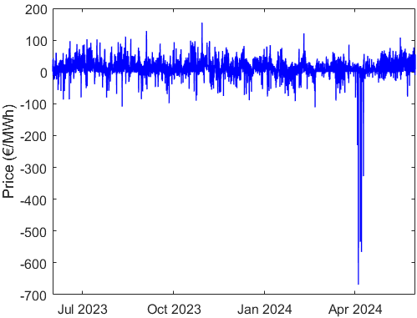
Figure 9.14. Hourly decreased mismatch cost (CoDsvBa).
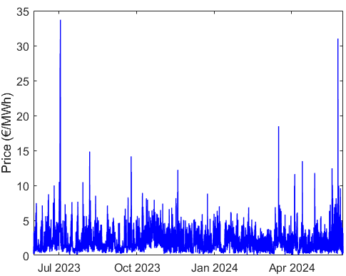
Figure 9.15. Hourly secondary band (BS3).
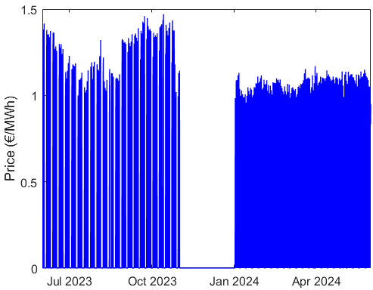
Figure 9.16. Hourly Daily Adjusted Reference (RAD3)
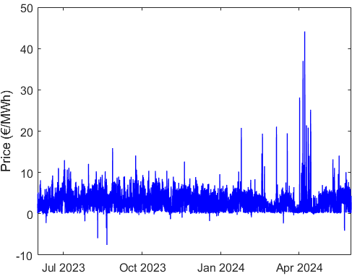
Figure 9.17. Hourly calculated mismatch (Dsv)
GdO: the certificate of renewable origin guarantees the renewable source of electricity and depends on the energy produced by the plants of the specific electricity provider and the costs of renewable certificates. This value is updated quarterly and is published in Som Energia [6]. For example, in Q3 2024, the GdO cost was 0.99 €/MWh.
POsOm: represents mandatory fees established by the National Commission of the Markets and the Competence to cover the costs of the system operator and market operator. The payment to the system operator, which refers to REE, is equally shared between direct consumers and electricity producers within the national territory (e.g., in 2024 the cost was 0.17498 €/MWh [7]). The payment to the market operator, which refers to OMIE, is directly paid by the consumer as part of the electricity tariff (e.g., in 2024 the value was 0.04096 €/MWh [8]).
Loss: this parameter accounts for the transmission and distribution losses, calculated as the difference between the energy injected to the generation point and the energy measured at the consumption point. Since consumers are billed according to their actual consumption, losses are applied as a percentage of the consumed energy. These losses are calculated from a fixed value based on the type of consumer, hour, and day [9], and an hourly correction calculated by the REE. Given that the real value of this parameter is not always available, the REE initially suggests an estimated coefficient (kest) until the real value is calculated (kreal). The data is included in the folder ‘CX_Liquicomun’ as ‘kreal’ and ‘kestimada’’ [5].
The losses are represented as a percentage (%) and are calculated according to Eq. (9.3):
$$loss=coeff_{loss}·k_{est} or loss=coeff_{loss}·k_{real}$$ | (9.3)
Being $coeff_{loss}$ the coefficient of losses set by the ministry and $k_{est}$ or $k_{real}$ the estimated or real losses.
Figure 9.18 shows the calculated losses considering the estimated losses (‘C2_Kestimado’) between 1st of June 2023 to 31st of May 2024 [5].
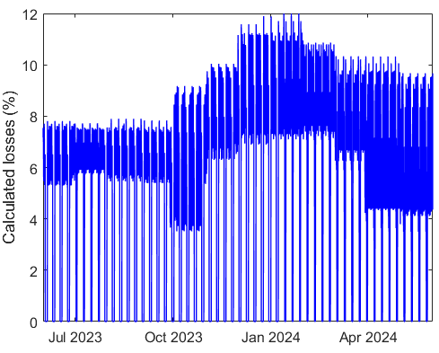
Figure 9.18. Hourly calculated losses (loss)
FE: is the contribution to the National Energy Efficiency Fund designed to finance the measures to meet the energy-savings objectives set by European policies. The Spanish ministry determines this fee dividing the total fund cost (without including the Energy Savings Certificate cost, defined as ‘CAE’ at ref. [10]) by the total energy sold two years prior. As an example of the year 2024, the total cost (369,970 €) is divided by the total energy sold in 2022 (379,326 MWh), resulting in 0.9753 €/MWh.
F: represents the pre-tax earnings of the electricity provider. In the case of Som Energia, the margin varies by the consumer scale, being 20 €/MWh for the small consumer, and 16 €/MWh for the medium and large consumers [6].
PtD: the transmission and distribution fees are set by the ministry for each type of consumer, hour of the day, day of the week and month [11].
CA: the system payment is fixed by the corresponding ministry for each type of consumer, hour of the day, day of the week and month [8]. It is used to finance the energy policies.
It should be noted that all the previous figures have different y-axis scale to ease data visibility given their variability.
Once the PH is calculated, the rest of the costs are applied, such as the power cost, reactive power (if applicable), penalty for the excess of consumed power, social bonus, electricity tax and energy meter rental fee. The resulting PH between 1st of June 2023 to 31st of May 2024 is plotted in Figure 9.19.
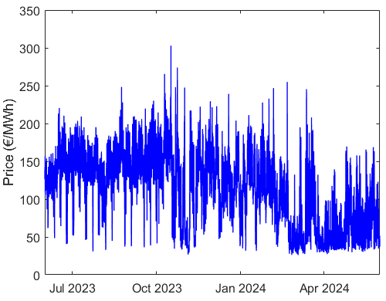
Figure 9.19. Hourly electricity cost before taxes (PH)

References:
[1] “Explicación tarifa indexada Som Energia”, Accessed: Aug. 12, 2025. [Online]. Available: www.somenergia.coop
[2] “Análisis | ESIOS electricidad · datos · transparencia.” Accessed: Aug. 11, 2025. [Online]. Available: https://www.esios.ree.es/es/analisis/805?vis=1&start_date=01-01-2024T00%3A00&end_date=31-01-2024T23%3A50&compare_start_date=31-12-2023T00%3A00&groupby=hour
[3] “OMIE.” Accessed: Aug. 11, 2025. [Online]. Available: https://www.omie.es/
[4] “BOE-A-2024-2774 Orden TED/113/2024, de 9 de febrero, por la que se establecen los precios de los cargos del sistema eléctrico y se establecen diversos costes regulados del sistema eléctrico para el ejercicio 2024.” Accessed: Aug. 11, 2025. [Online]. Available: https://www.boe.es/diario_boe/txt.php?id=BOE-A-2024-2774
[5] “Descargas | ESIOS electricidad · datos · transparencia.” Accessed: Aug. 11, 2025. [Online]. Available: https://www.esios.ree.es/es/descargas?date_type=publicacion&start_date=01-01-2024&end_date=31-01-2024
[6] “Històric Tarifa indexada.” Accessed: Aug. 12, 2025. [Online]. Available: https://www.somenergia.coop/ca/historic-tarifa-indexada
[7] C. DE Nacional Los Mercados Y La Competencia, “III. OTRAS DISPOSICIONES COMISIÓN NACIONAL DE LOS MERCADOS Y LA COMPETENCIA,” 2023, Accessed: Aug. 13, 2025. [Online]. Available: https://www.boe.es
[8] M. LA Para Transición Ecológica Y El Reto Demográfico, “I. DISPOSICIONES GENERALES MINISTERIO PARA LA TRANSICIÓN ECOLÓGICA Y EL RETO DEMOGRÁFICO,” 2024, Accessed: Aug. 13, 2025. [Online]. Available: https://www.boe.es
[9] Núm, “BOLETÍN OFICIAL DEL ESTADO COMISIÓN NACIONAL DE LOS MERCADOS Y LA COMPETENCIA”, Accessed: Oct. 24, 2025. [Online]. Available: https://www.boe.es
[10] M. LA Para Transición Ecológica Y El Reto Demográfico, “I. DISPOSICIONES GENERALES MINISTERIO PARA LA TRANSICIÓN ECOLÓGICA Y EL RETO DEMOGRÁFICO 5841,” 2024, Accessed: Aug. 13, 2025. [Online]. Available: https://www.boe.es
[11] C. DE Nacional Los Mercados Y La Competencia, “III. OTRAS DISPOSICIONES COMISIÓN NACIONAL DE LOS MERCADOS Y LA COMPETENCIA,” 2024, Accessed: Aug. 13, 2025. [Online]. Available: https://www.boe.es

